241-[LX]-Lab - Managing Services and Monitoring

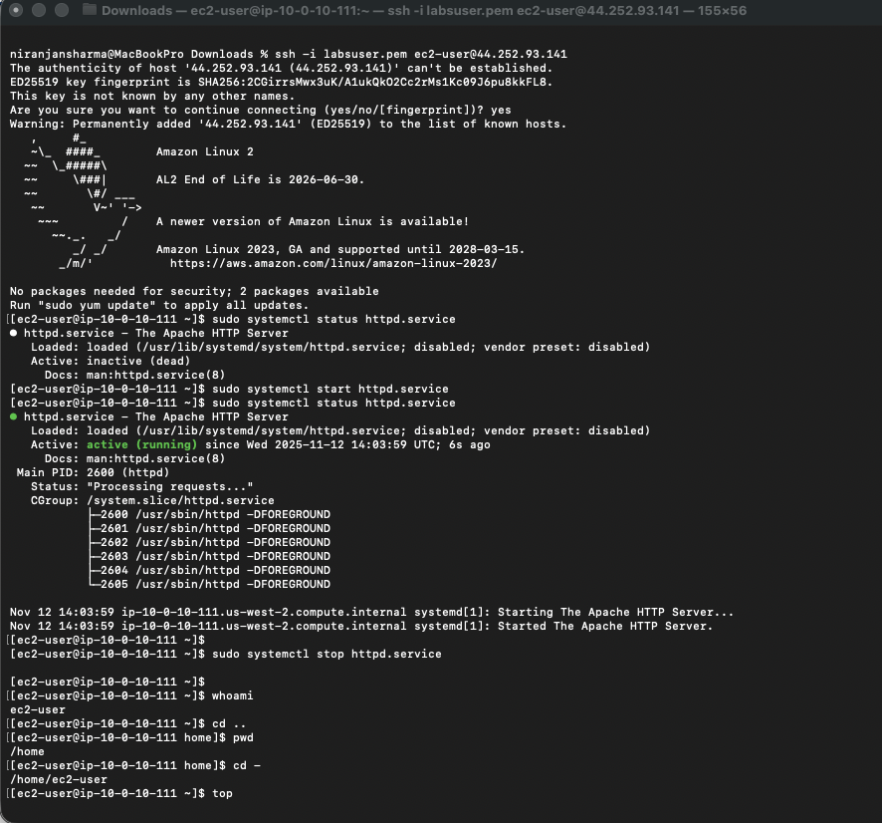

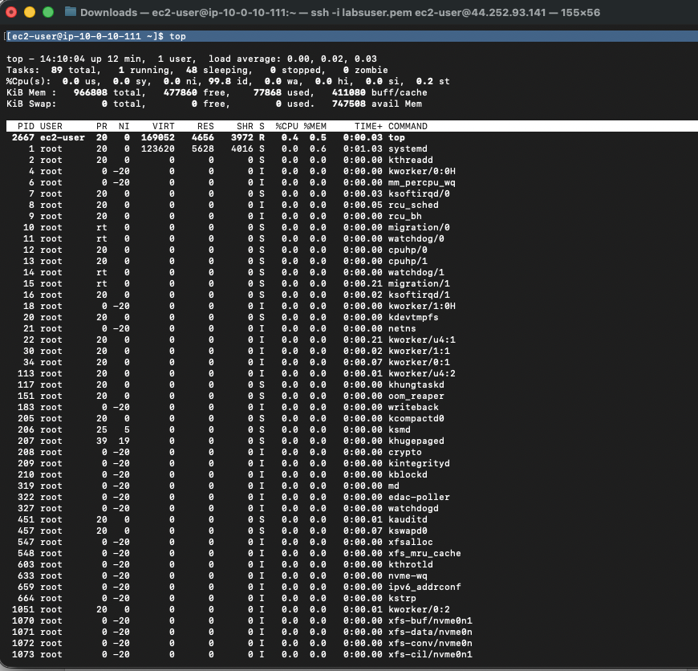

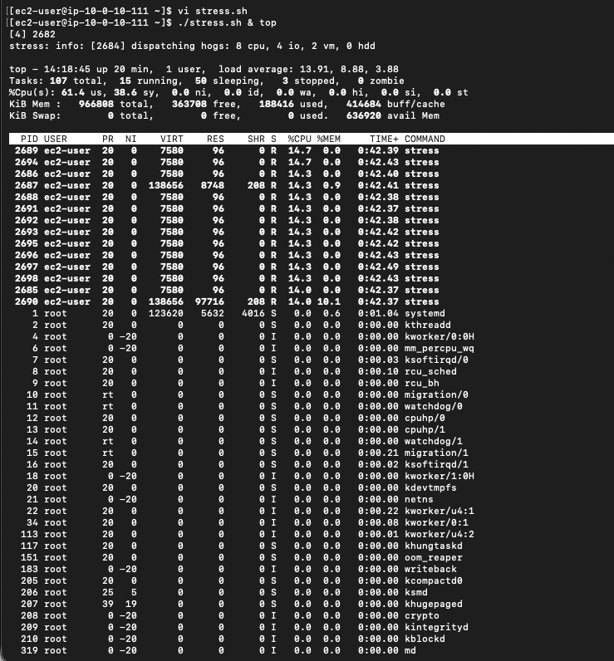

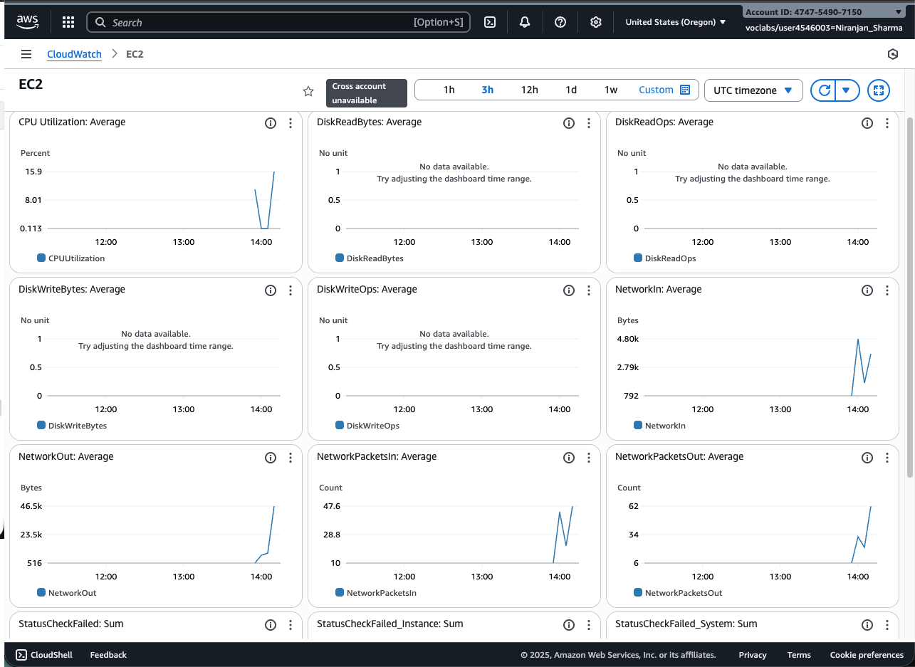

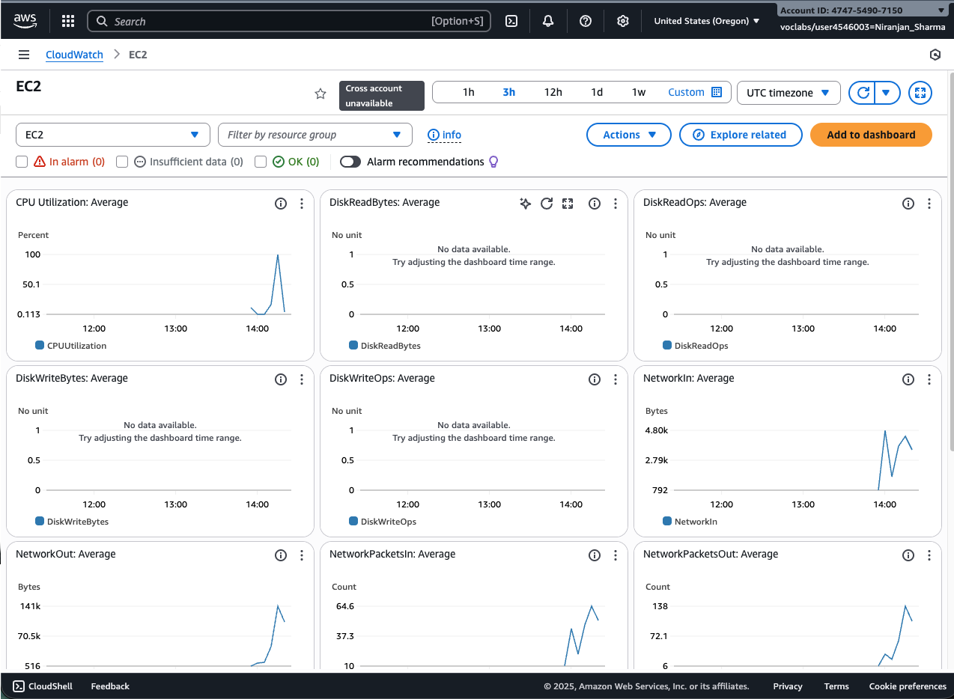

249-[LX]-Lab - The Bash Shell

251-[LX]-Lab - Bash Shell Scripts

243-[LX]-Lab - Software Management

245-[LX]-Lab - Managing Log Files

File Creation Challenge

